**CHALLENGE #2**

**Underwater Photography Noise Cancellation**

**using Artificial Intelligence and Deep Learning**

**Problem definition**

1. Image Enhancement is a process to make a input image more accurate by sharpening image features like Contrast.
2. Underwater Images which are important source of interest for scientific research , suffers poor visibility due to dust/noise present underwater.
3. Our aim is to introduce an effective technique to enhance the images captured underwater and degraded due to the medium scattering and absorption of the water medium and providing a more Clearer image from a Noisy Image.

**Proposed solution**

1. Whenever there is noise in an image, the camera has failed to capture the color information for those pixels and hence to fill the ‘no color’ in those pixels, mostly it fills with some random value by the camera software. To restore the image to its original form, we need to rectify those corrupted pixel values.
2. In our method, we address two main issues in underwater images, namely noise in the image due to the scattering of light and poor contrast of the image due to low lighting.
3. The most effective way of noise removal is by convolving the image with filters These filters are mainly low pass filters. A low pass filter is also called a blurring or smoothing filter.
4. A bilateral filter is an edge preserving filter that replaces each pixel value with the average intensity of its neighboring pixel values.
5. In the proposed method, a bilateral filter with a gaussian trigonometric function is used. This makes the computational **complexity of O(N)** which is more efficient than the state of art bilateral filtering methods.
6. **CLAHE** is applied to remove partial noises, thus improving the contrast of the image.
7. For accomplishing this, the image is first converted to its frequency domain.
8. The high pass filter makes the image appear sharper, emphasizing the fine details of the image by using a different convolutional kernel.
9. The **CNN**(convolutional neural network) is used to remove the unwanted noise in the image.
10. The images are fed to a convolutional neural network for the removal of noise.
11. The filter is computed based on the bilateral trigonometric method. The image is passed through a denoised bilateral filter which reduces noise in the image through a blurring effect.
12. It replaces the intensity of each pixel in the image using the weighted average of its neighboring pixels. This weight is based on a Gaussian distribution.
13. The last phase of the network is to apply CLAHE which improves the lost contrast of the image due to noise removal.
14. The resultant image is an enhanced and noise-removed image.

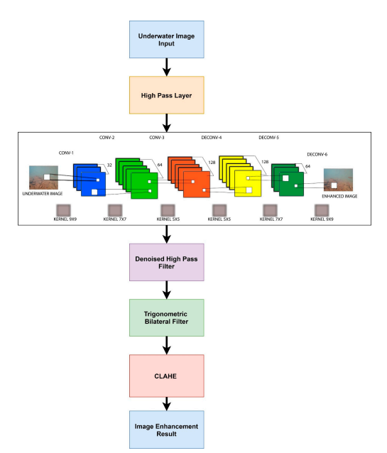

**Key technologies**

1. CNN (convolutional neural netwrok) : A neural network model used
2. Python : Language used
3. Matplotlib : Python library
4. CLAHE : Contrast Limited Adaptive Histogram Equalization is an contrast enhancing algorithm.

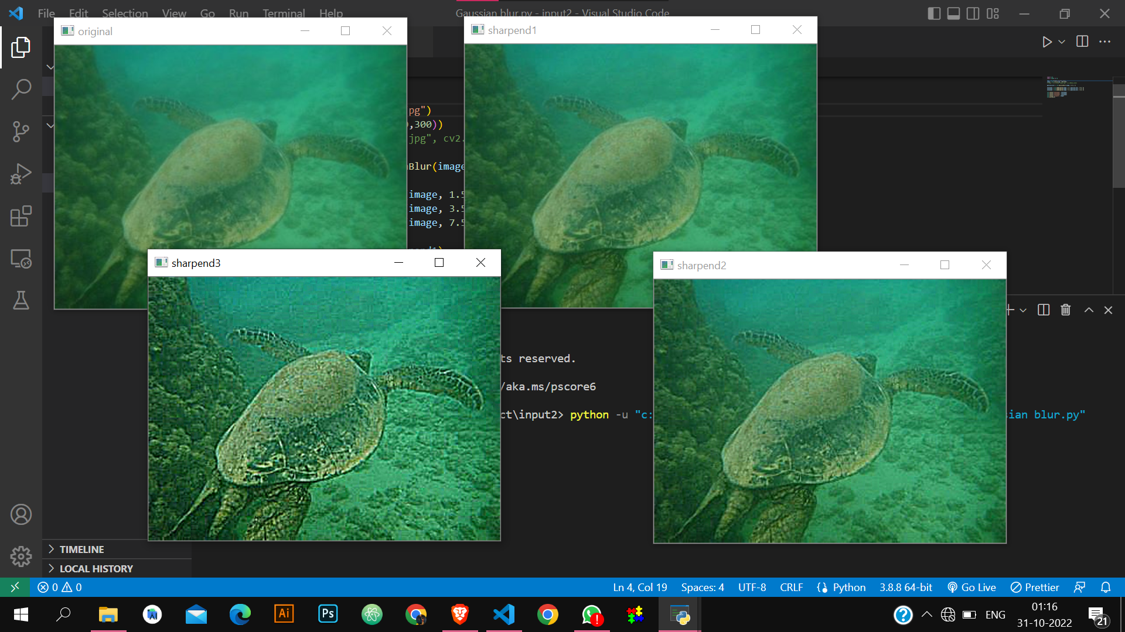

**Key functionality**

1. The proposed method uses the deep learning method to remove the noise and haze from underwater images.
2. The proposed method is said to outperform the existing method based on its run time complexity and increased resolution of the reconstructed image.
3. The computational complexity of the traditional bilateral filter is O(N^2 ). The proposed method applies a trigonometric filter which has a complexity of O(N) This proves that it is more efficient than the state-of-the-art bilateral filtering methods.
4. The noise in the underwater images caused by particles such as dust, sediments, and haze is removed by passing the image through a convolutional neural network (CNN).

**Commercial advantages**

1. Under-water sensing and image processing play major roles in oceanic scientific studies.
2. Underwater image filteration is being adapted by marine scientists for on-site coral reefs monitoring For classification of Coral Reefs .
3. For Aqua Tourism to make the images Underwater more attractive.